SCHOOL OF COMPUTER SCIENCE AND ARTIFICIAL INTELLIGENCE |  |  |  |  | DEPARTMENTOF COMPUTER SCIENCE ENGINEERING
ProgramName:M. Tech/MCA/MSC |  |  |  | AssignmentType: Lab |  |  | AcademicYear:2025-2026
CourseCoordinatorName |  |  |  | Venkataramana Veeramsetty
CourseCode |  |  |  | CourseTitle |  | AI Assisted Problem Solving Using Python
Year/Sem |  |  | II/I | Regulation |  | R24
DateandDay  of Assignment |  |  | Week5- Monday | Time(s)
Duration |  |  | 2 Hours | Applicableto  Batches
AssignmentNumber:11.3(Presentassignmentnumber)/24(Totalnumberofassignments)
 | Q.No. | Question |  |  |  |  |  | ExpectedTime  to complete
 | 1 | Lab 11 – Data Structures with AI: Implementing Fundamental Structures  Lab Objectives  - To implement fundamental data structures with the assistance of AI tools.  - To understand how AI suggests different implementations and optimizations.  - To analyze the readability, correctness, and performance of AI-generated code.  - To reinforce problem-solving skills using AI-powered coding assistance.  Learning Outcomes  After completing this lab, students will be able to:  - Implement stack, queue, and linked list using Python with AI support.  - Use AI tools to optimize and refactor basic data structure operations.  - Compare multiple AI-suggested implementations for the same structure.  - Apply AI assistance to generate test cases for verifying data structure behavior.  - Demonstrate understanding of trade-offs in AI-generated solutions.  Task Description #1 – Stack class implementation  Task: Ask AI to implement a stack class with push(), pop(), peek() and is_empty() methods  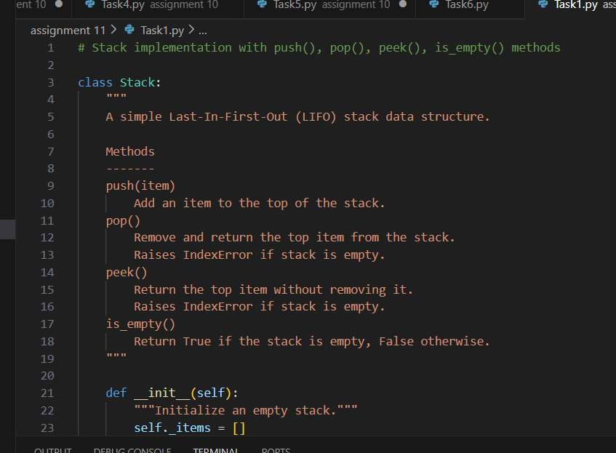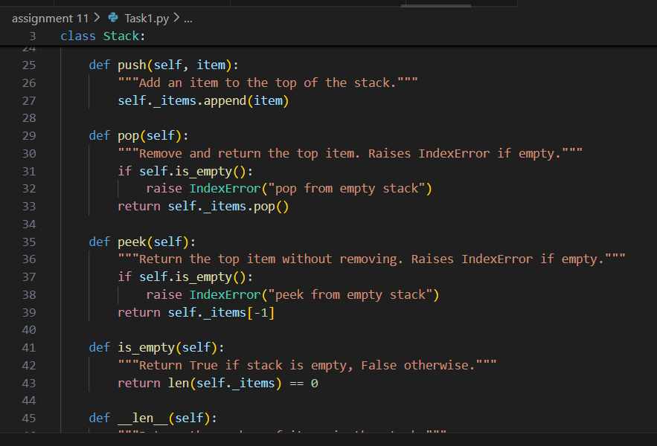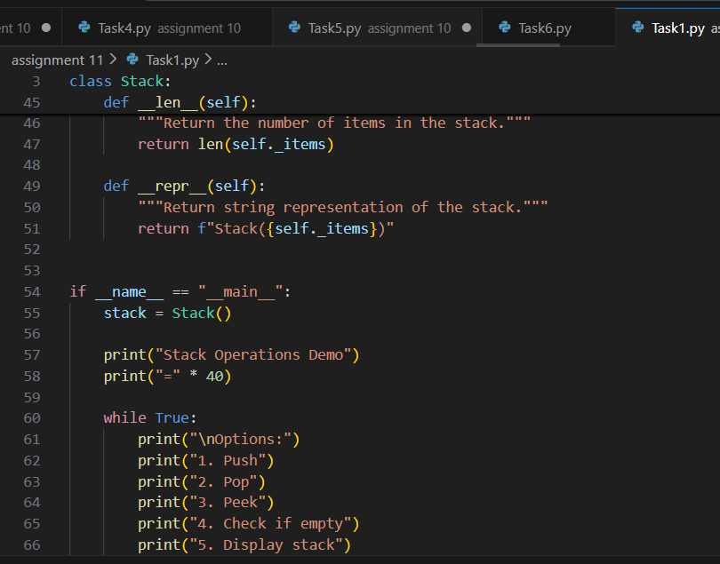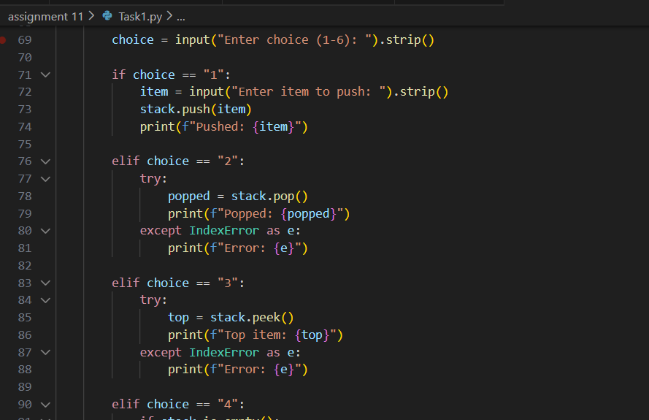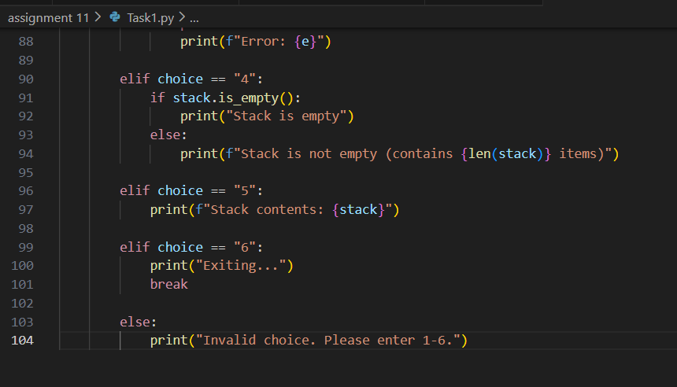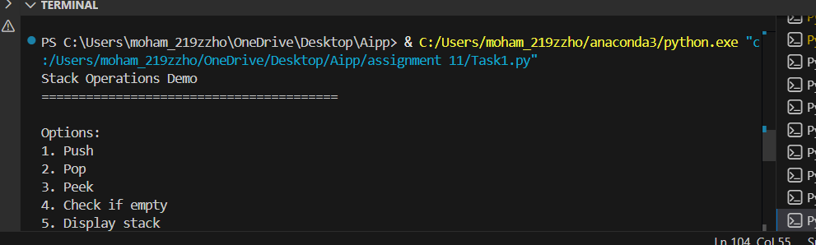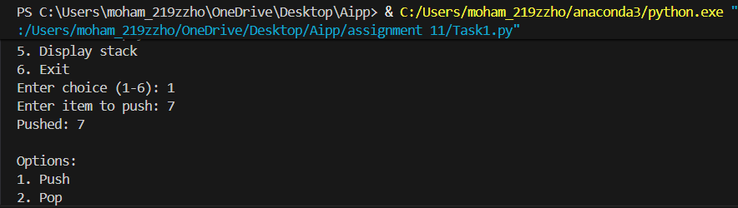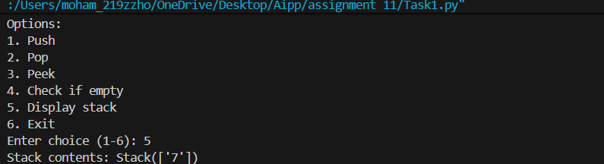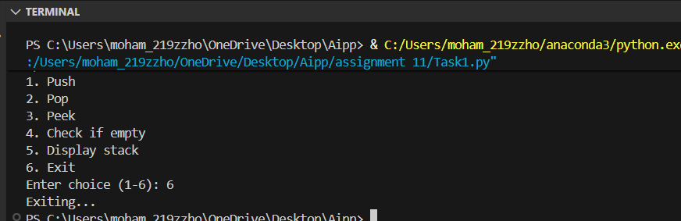  Task Description #2 – Queue Implementation  Task: Use AI to generate a Queue class with enqueue(), dequeue(), and is_empty().  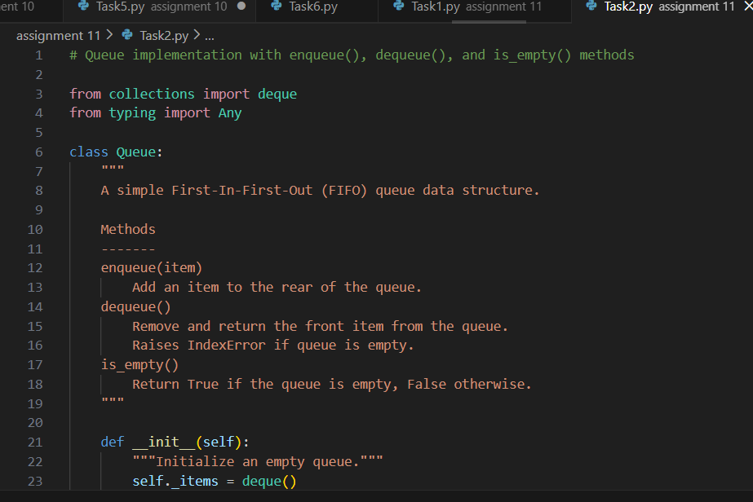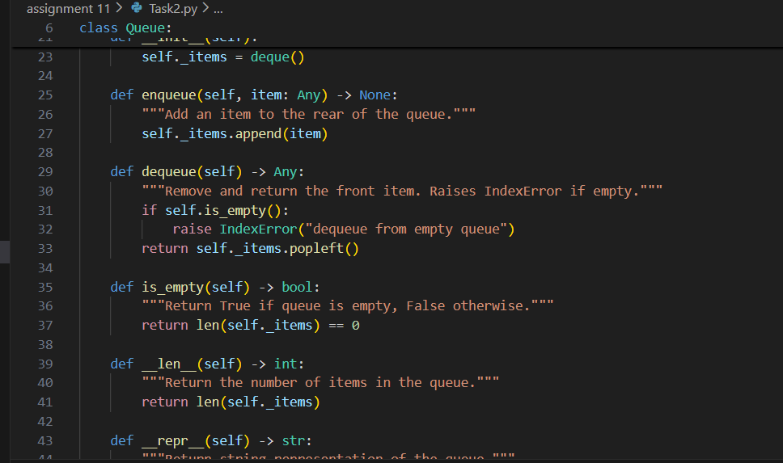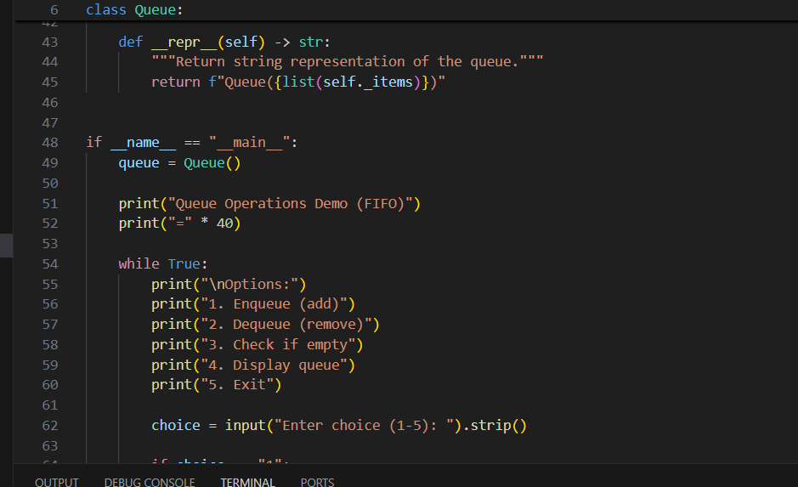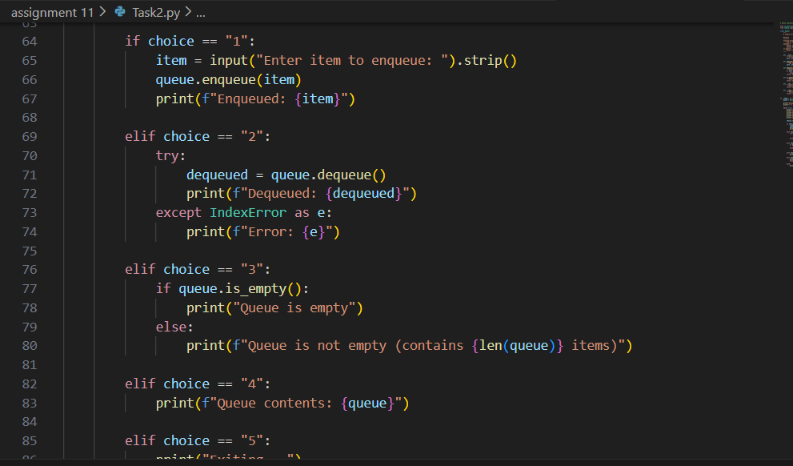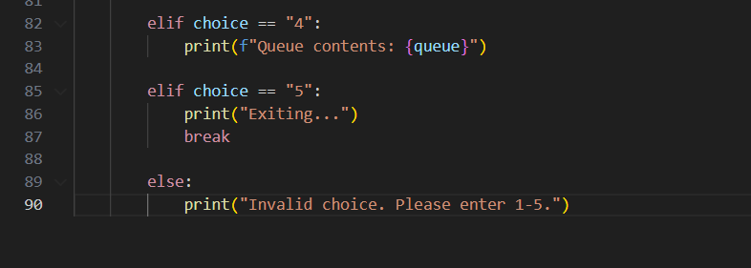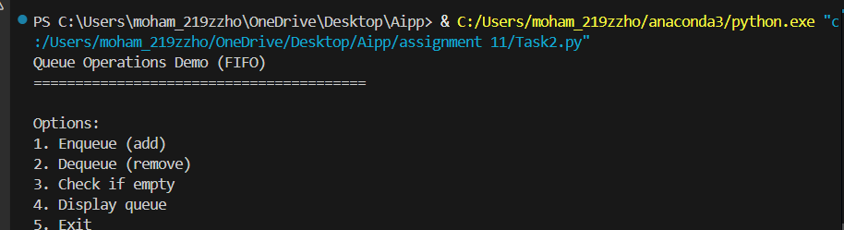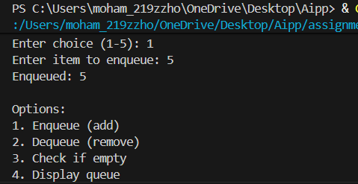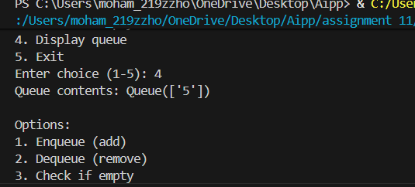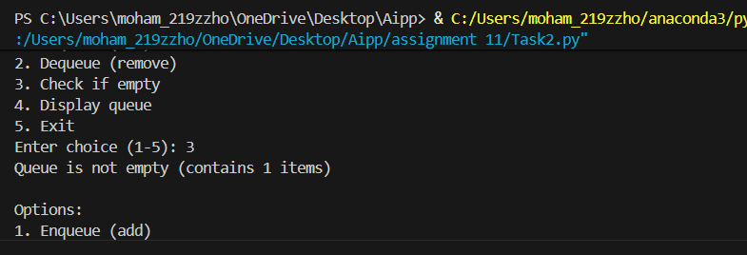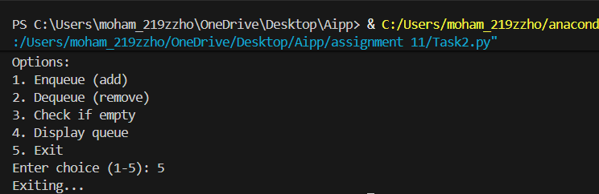  Task Description #3 – Linked List Implementation  Task: Ask AI to create a singly linked list with insert_at_end(), insert_at_beginning(), and display().  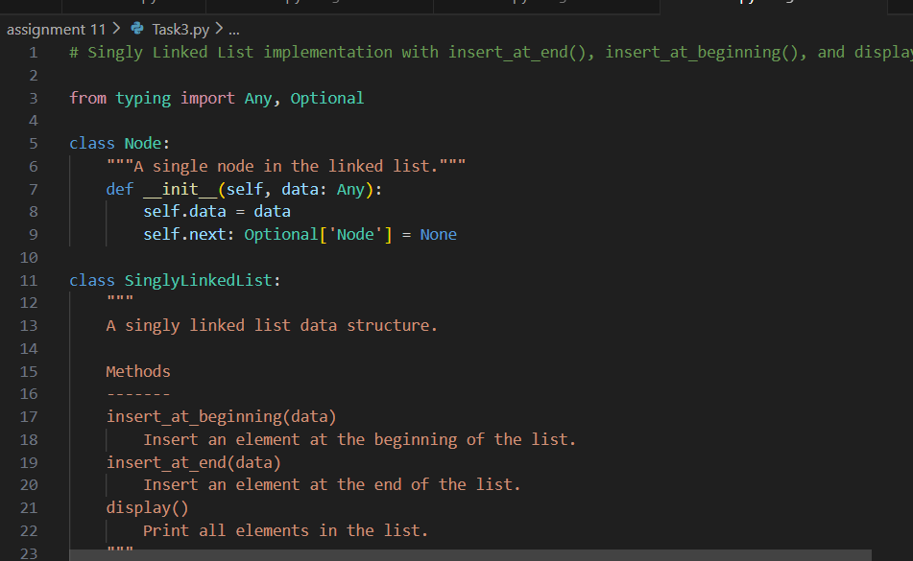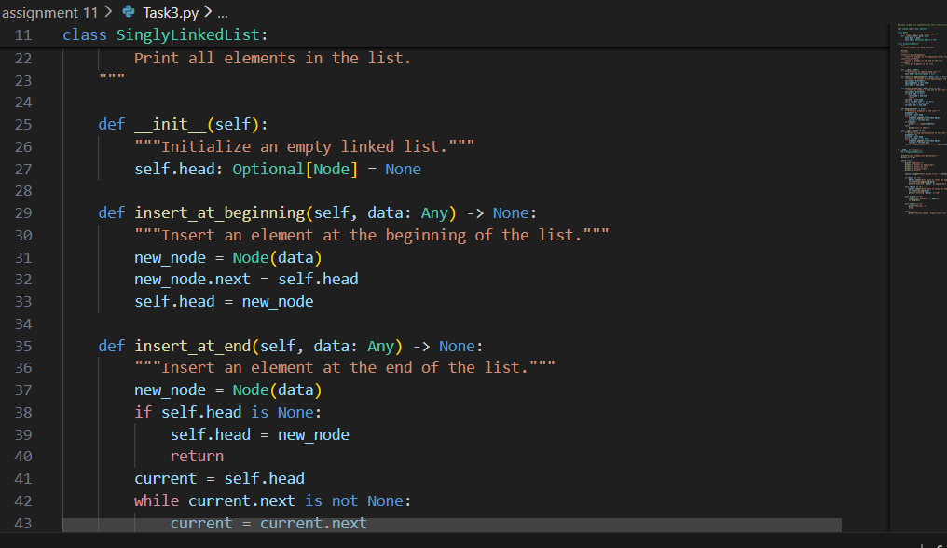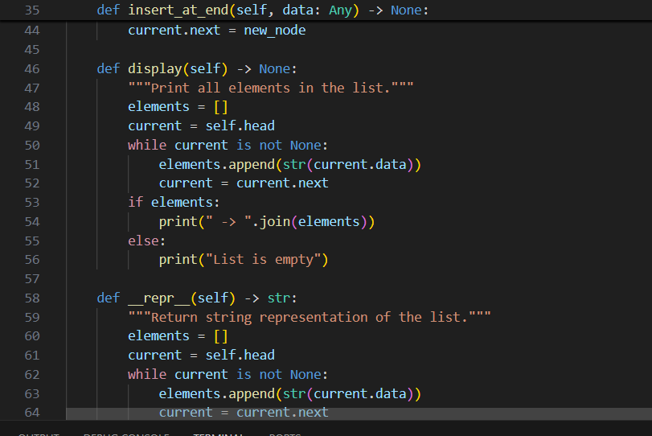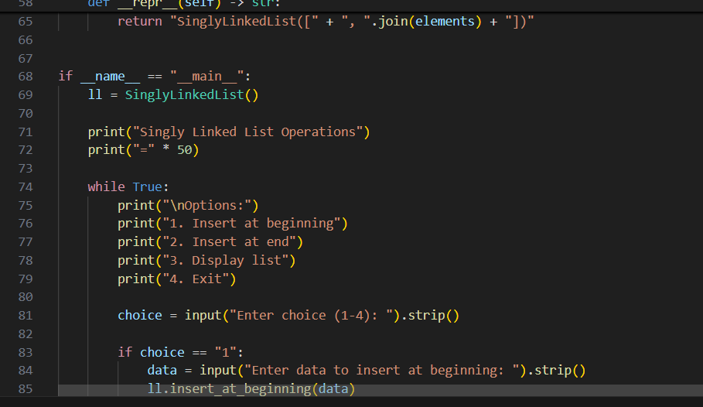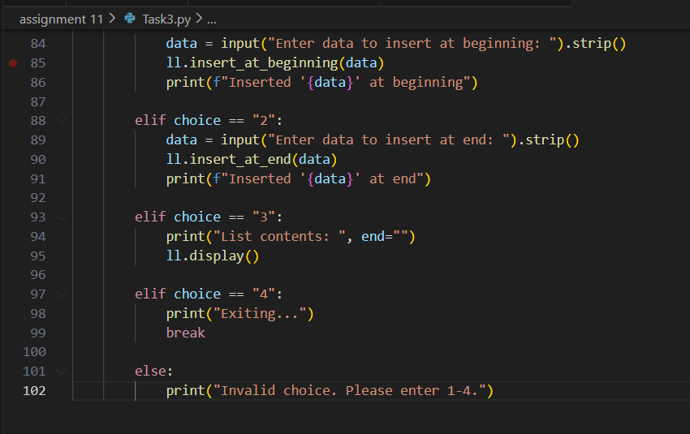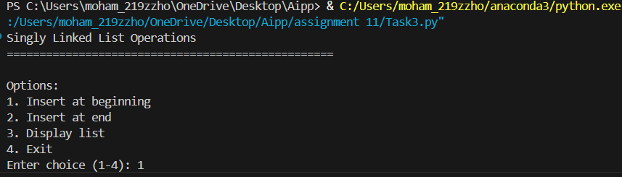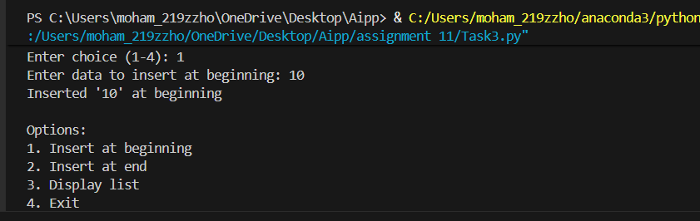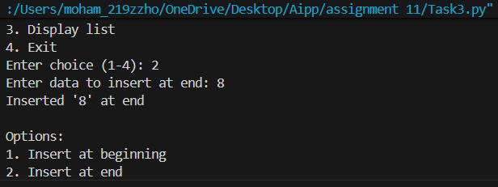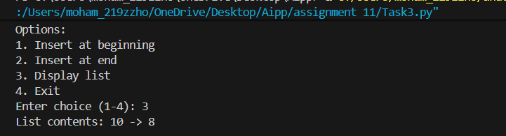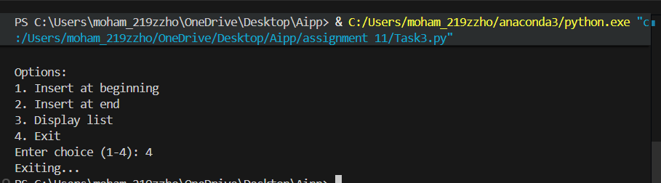  Task Description #4 – Binary Search Tree (BST)  Task: Ask AI to generate a simple BST with insert() and inorder_traversal().  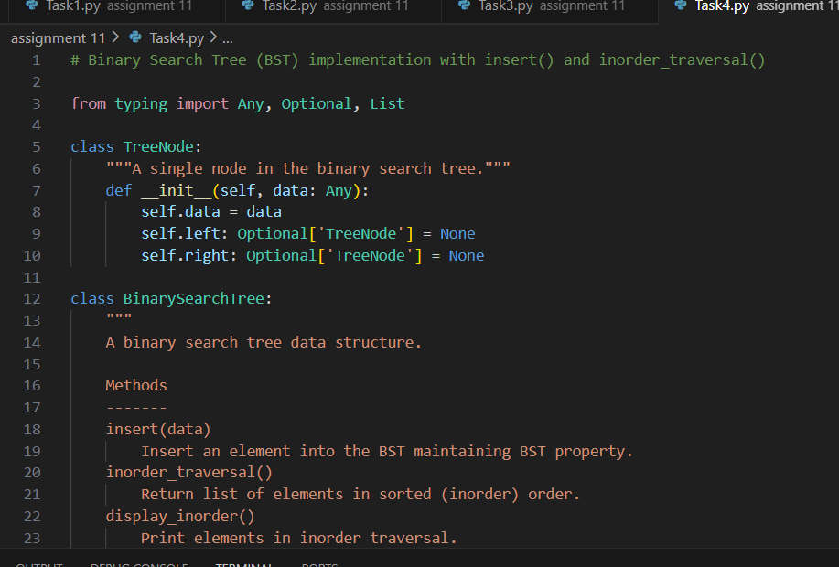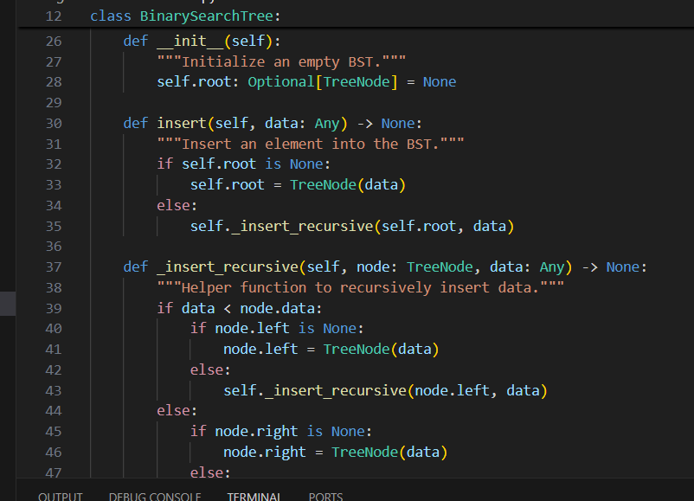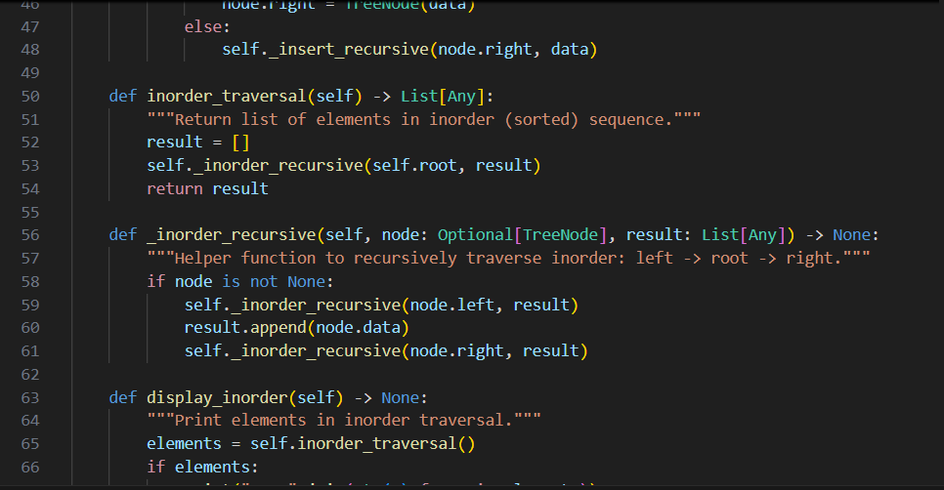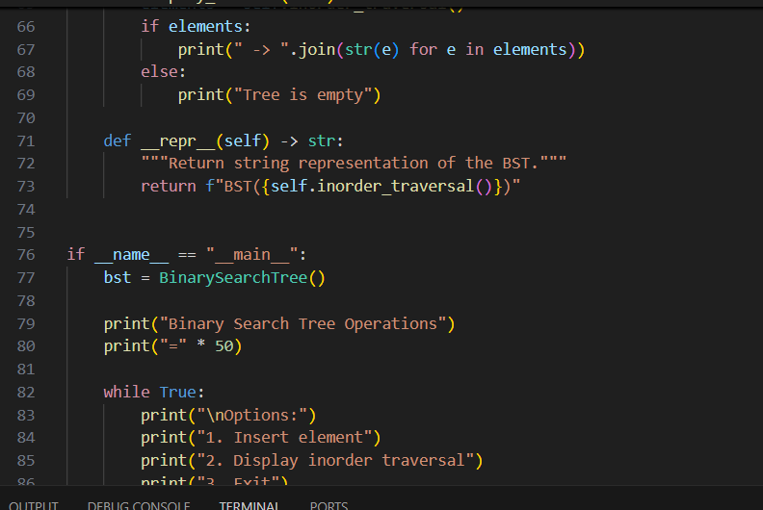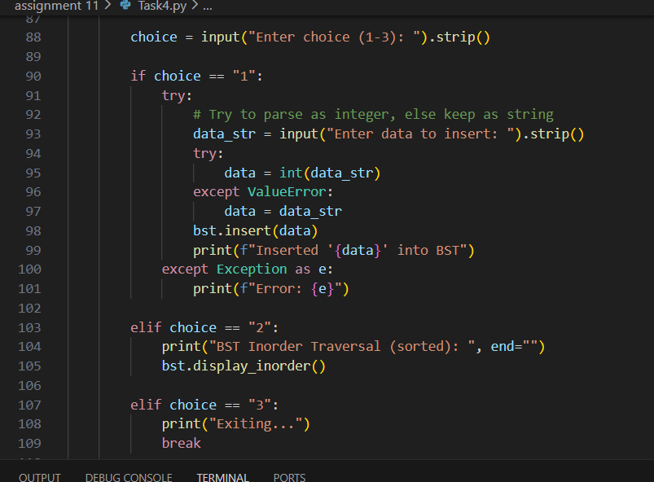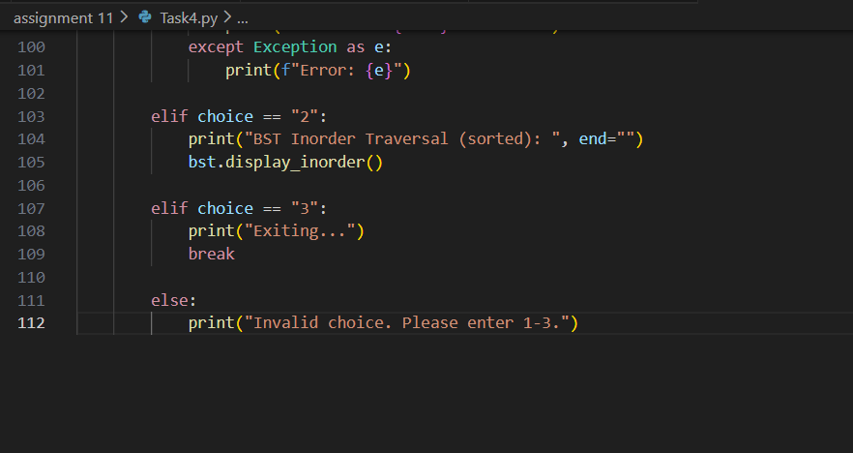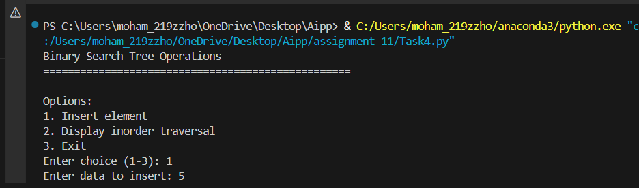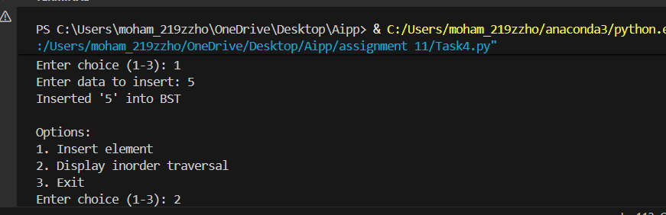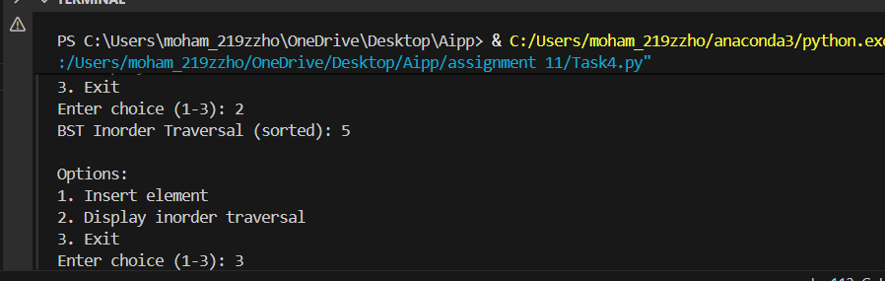 |  |  |  |  |  | Week5 - Monday

